

Vijay Dialani  
Cloud Computing

Boise State CS597 VMware Cloud

# Where TO start?

Cloud computing setup for course CS597 consists of two different types of installation a VMWare© based solution and an Openstack© based solution. To start provisioning VMs and creating resource pools in the BSU cloud, please visit the web site <https://132.178.129.28/> and install the tools by visiting the vSphere Client link on the web page.

# What WILL I NEED?

1. You would need a Windows 7/8 or a Redhat Linux or a SUSE linux machine
2. Your login to the vSphere Client is your first name
3. Your default password is CS597BSU!, make sure you change it after login
4. We are using version 5.5 of the VSphere from VMWare, please make sure you refer to the document

With these four things you are good to start developing your own custom cloud.

## Where To find the documentation for vsphere client

<http://pubs.vmware.com/vsphere-50/index.jsp> provides the latest documentation for managing the private cloud.

# What DO I DO NEXT?

For creating your own virtual cloud environment, you need to determine the type and number of VMs that you would like to create. Once you login following screen will appear

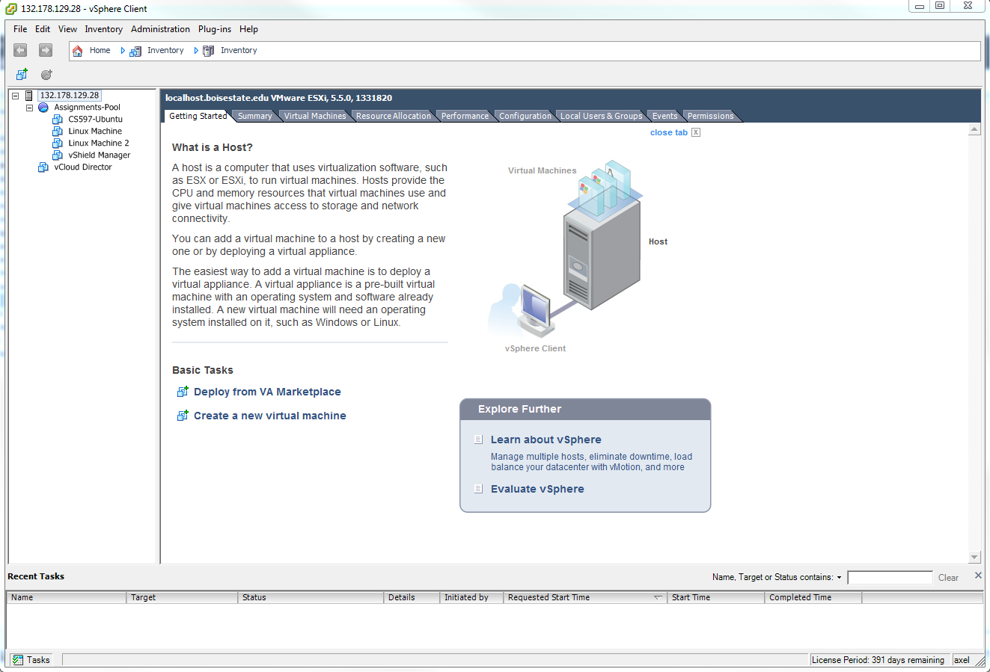

Step 2: Create a new VM: Right click the server ip address in the left pane and select new Virtual machine installation

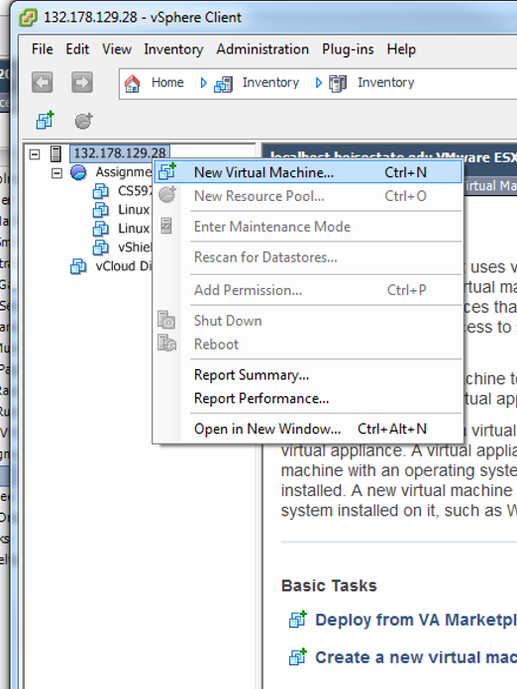

Follow the instructions below:

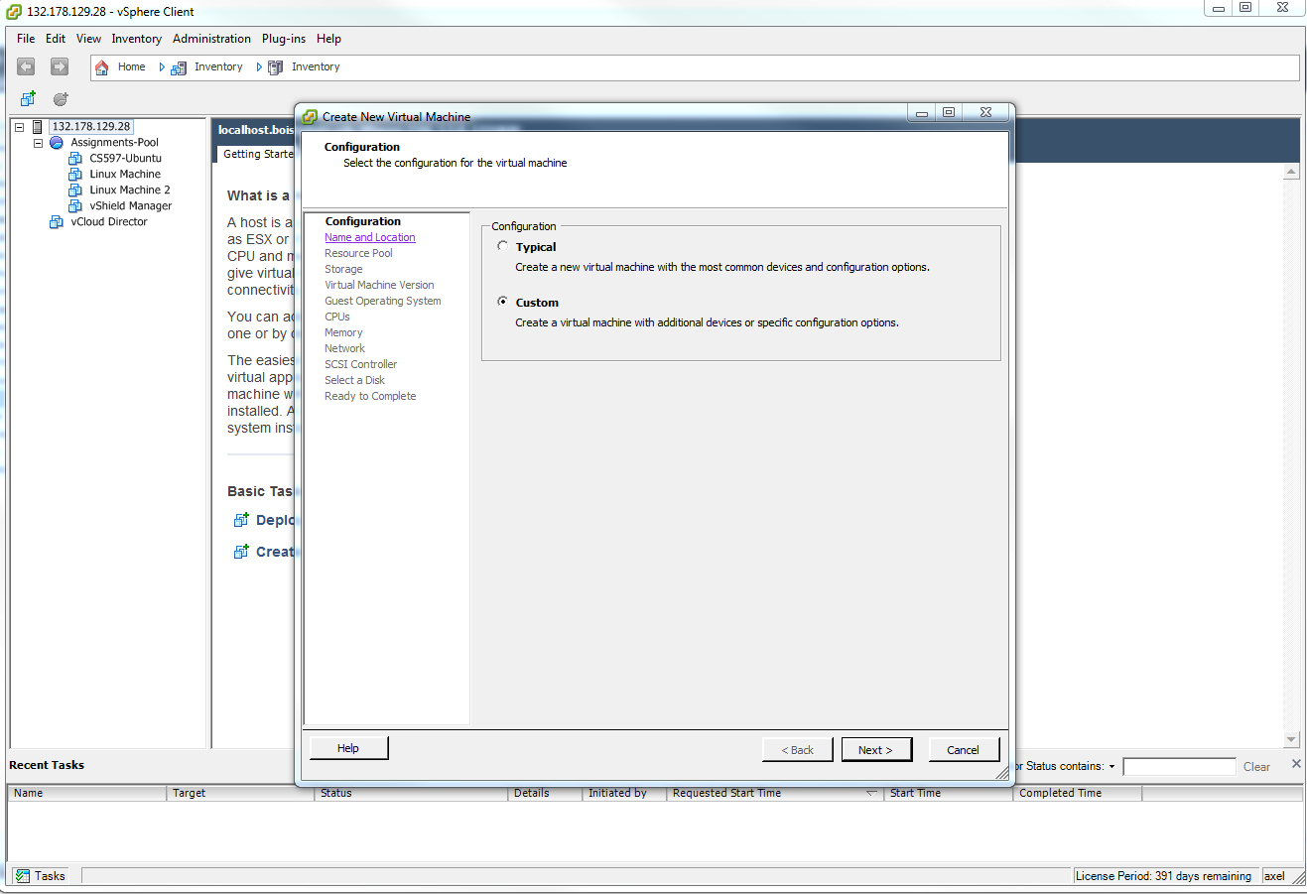

Next select the name and the location 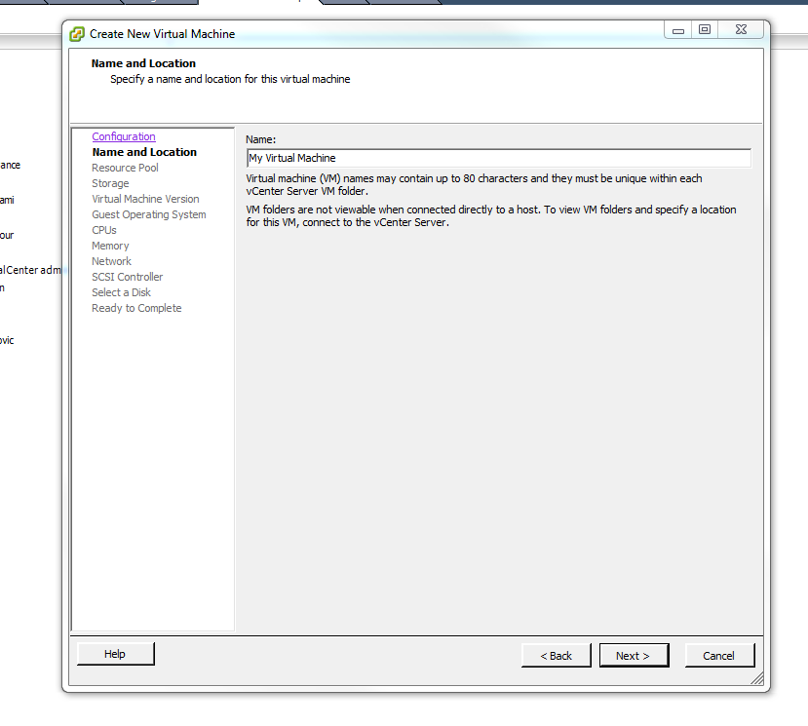

Select the appropriate resource pool

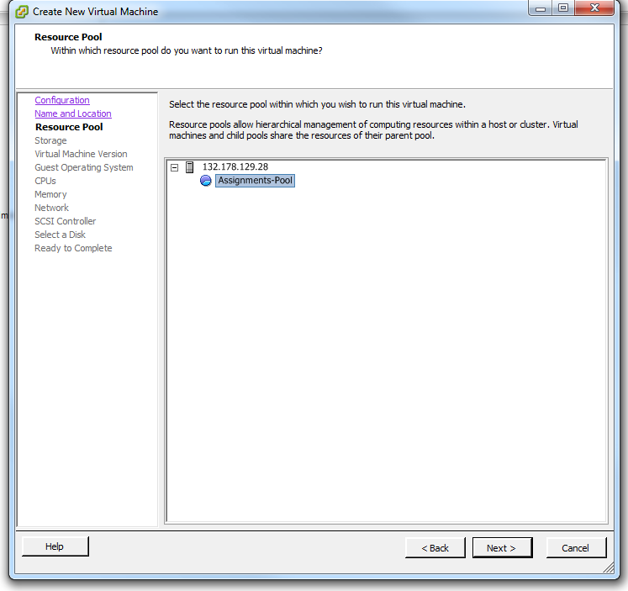

Select the Non-SSD datastore

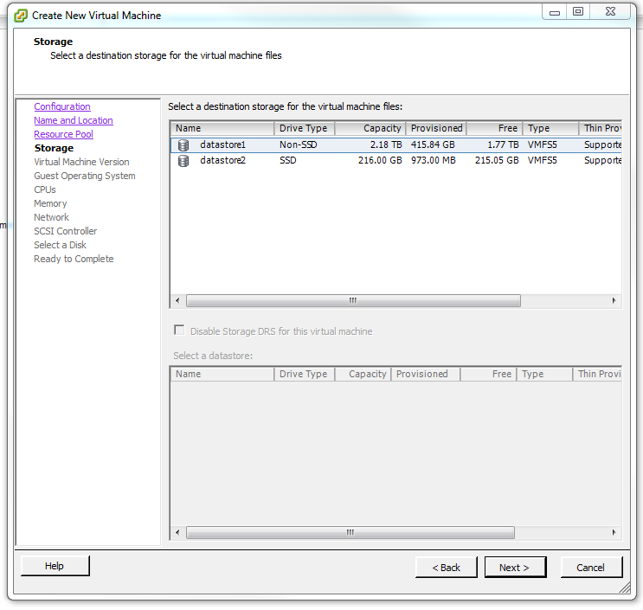

Select latest version of the VM

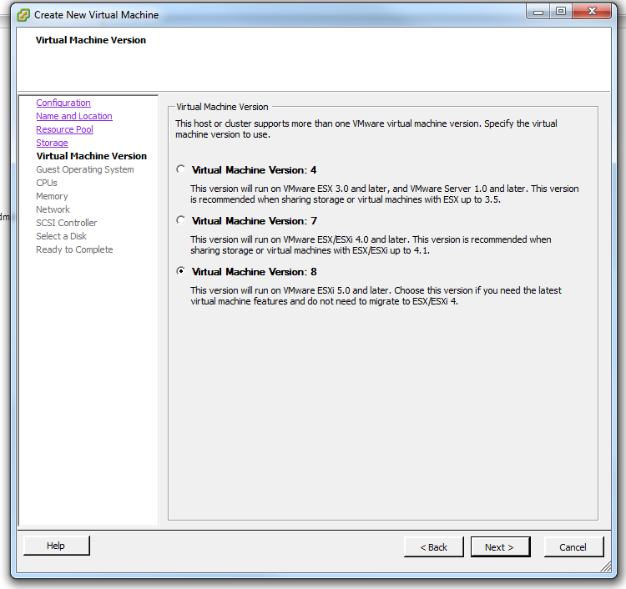

Choose appropriate Guest operating System

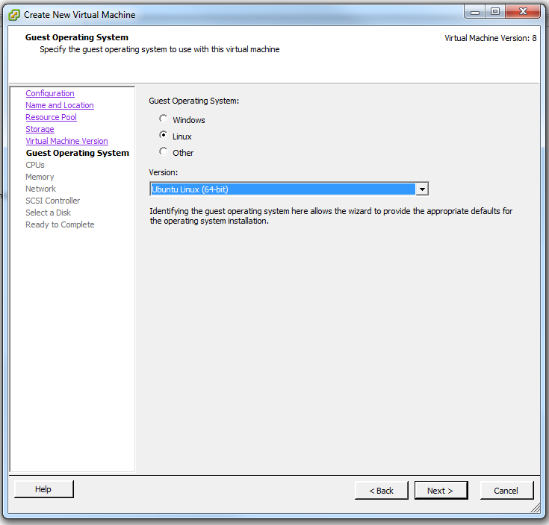

Choose appropriate number of cores, the maximum allowed for this configuration is 32, but try to create smaller machines first

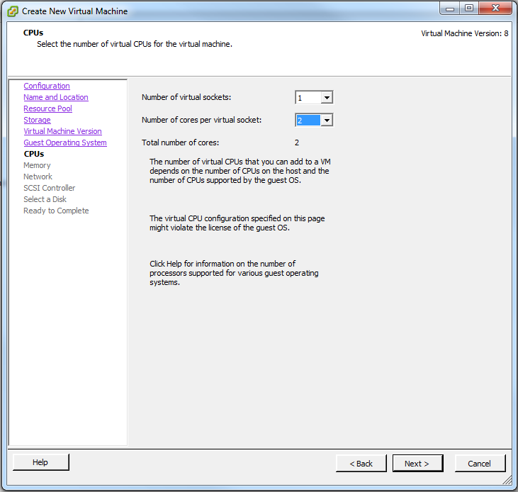

Select a memory between 4GB to 32GB depending upon your needs

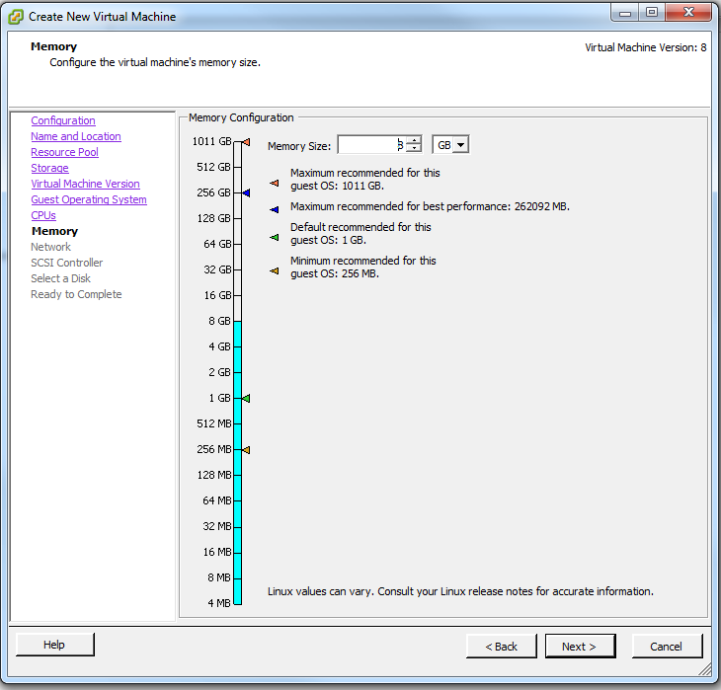

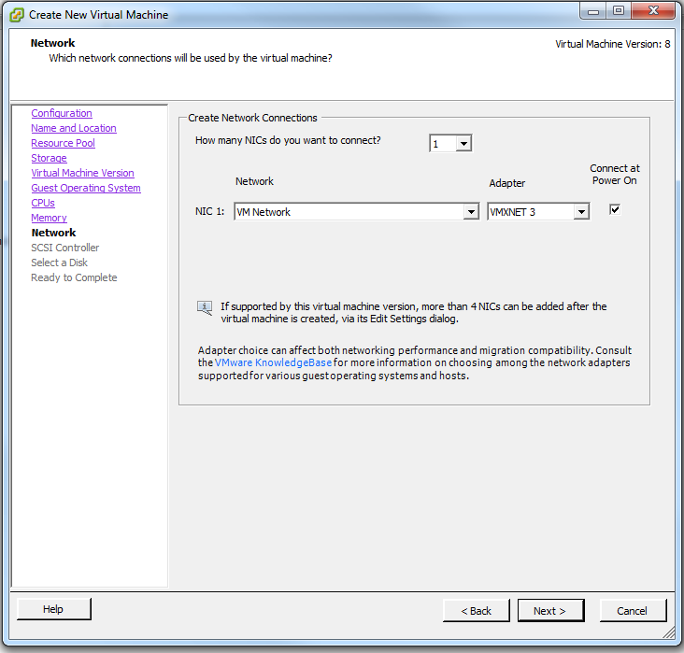

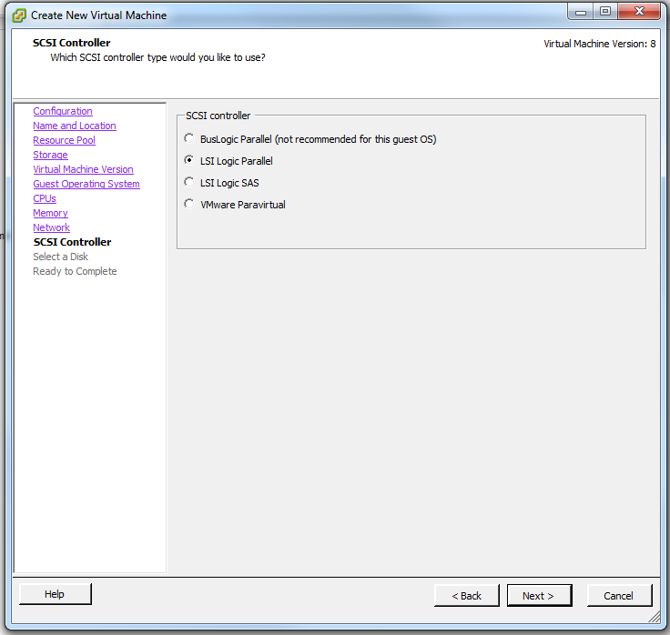

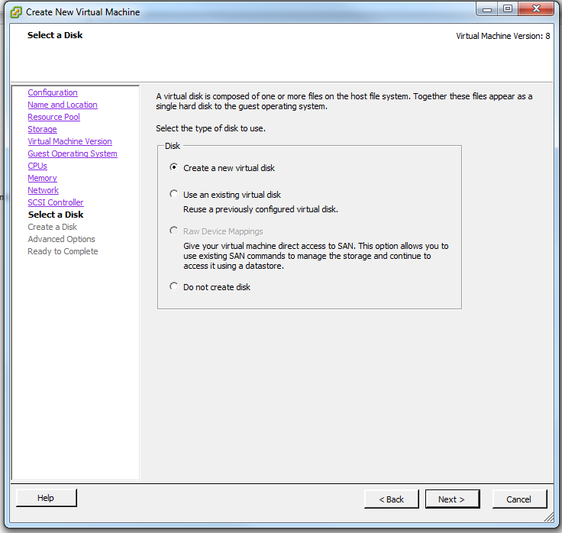

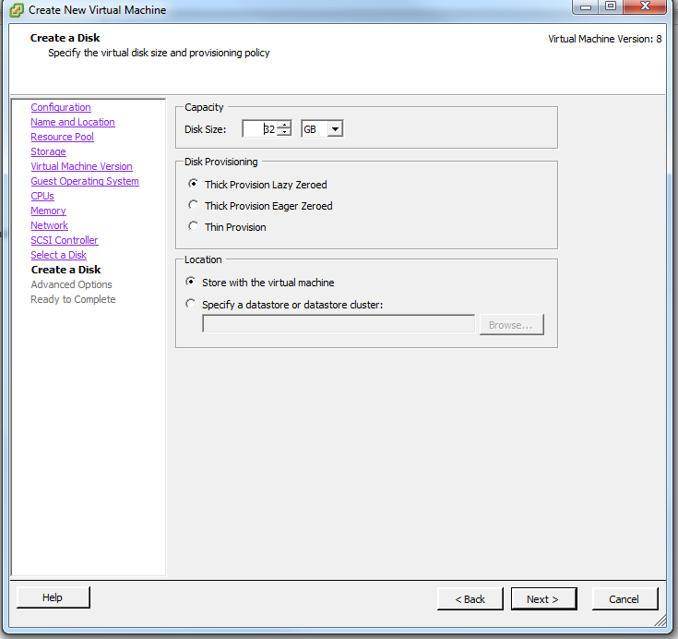

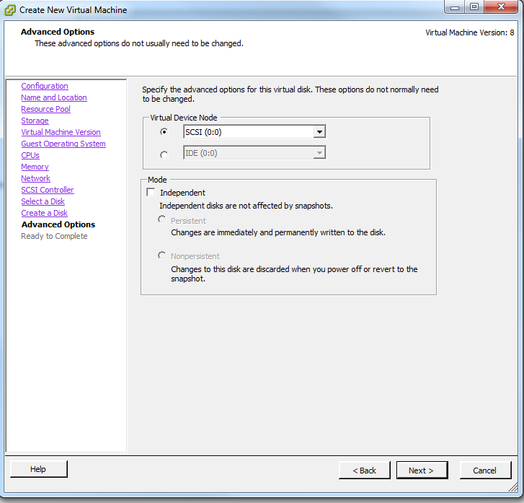

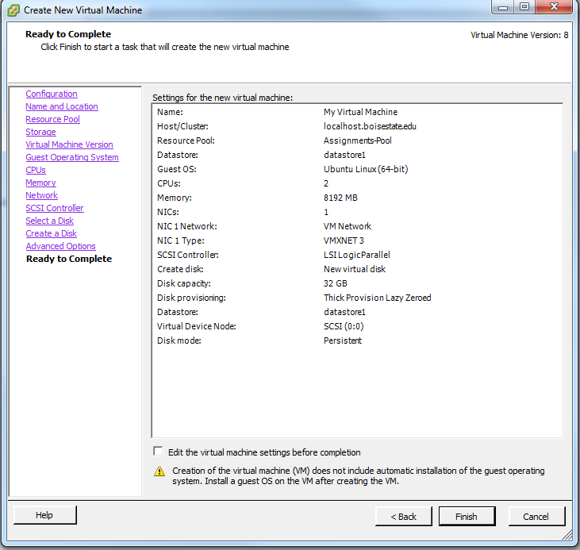

Your Virtual machine is now ready

